

Mohammad Ali Jinnah University

Chartered by Government of Sindh - Recognized by HEC

**Assignment 1**

**Name:** Muhamad Fahad

**Id:** FA19-BSSE-0014

**Subject:** [Principles of Psychology](https://classroom.google.com/u/0/c/MTk5ODAxMTk5ODE4)

**Section:** EM

**Teacher:** SAFIA DOST MUHAMMAD

**Date:** Sunday, November 8, 2020

**Assignment 1**

**Q1)** Select a movie or documentary or a book on a psychological concept and elaborate the following:

* Which psychological concept does it cover?
* Why you select it.
* Brief summary.
* What did you learn from it
* How did it changed you?

**Answer:**

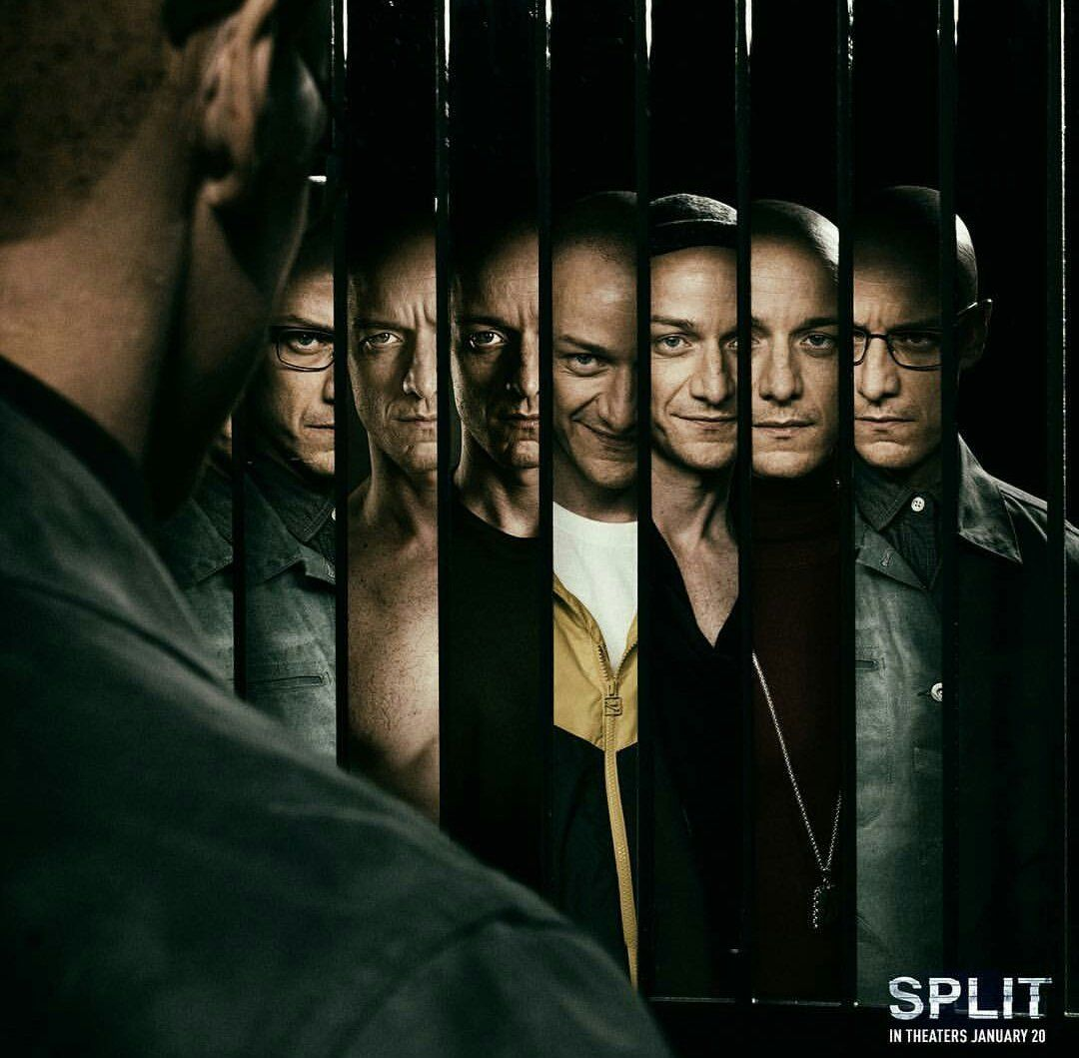

**Movie Name:** Split (2016).

**Release Date:** January 19, 2017.

**Writer:** [M. Night Shyamalan](https://www.google.com/search?q=M.+Night+Shyamalan&stick=H4sIAAAAAAAAAONgVuLQz9U3yCoqLHzEaMwt8PLHPWEprUlrTl5jVOHiCs7IL3fNK8ksqRQS42KDsnikuLjgmngWsQr56in4ZaZnlCgEZ1Qm5ibmJOYBAE9d6XFXAAAA).

# **Psychological Concept:**

In this movie we are able see the psychological disorder (Dissociative Identity Disorder). **Dissociative identity disorder** (previously known as **multiple personality disorder**) is thought to be a complex **psychological condition** that is likely caused by many factors, including severe trauma during early childhood (usually extreme, repetitive physical, sexual, or emotional abuse).

# **Movie Select (reason):**

I was search for Psychological Movie and on my recommended list the movie then came the post/Cover picture attract me.

# **Summary:**

As the movie begin there is a girl who is invited to a birthday party at the mall, she accepts a ride home from her classmate father, who also takes friend of her daughter. As the girls wait in the car, a man who is suffering from [dissociative identity disorder](https://en.wikipedia.org/wiki/Dissociative_identity_disorder) (DID) knocks car unconscious before kidnapping them.

The man is in therapy with his Doctor, who has identified 23 distinct personalities formed after he was abused as a child by his mother after his father left on a train one day and never returned. The dominant personality, real personality, controls when and which of the others can manifest. Real personality has not allowed two personality to have control due to their undesirable traits and their belief in "The Beast", a 24th personality who plans to rid the world of the "impure", those who have not suffered. Fletcher recognizes in their sessions that "Dennis" has recently displaced "Barry" as the dominant personality.

"Dennis" imprisons the girls in an underground cell. By taking advantage of a childlike personality called "Hedwig", the girls attempt to escape and Casey manages to find a walkie-talkie but her attempts to obtain help are dismissed as a prank. The girls are separated from each other by "Dennis" and "Patricia". Fletcher visits The Man's quarters, where he reveals that he has met "The Beast". Fletcher realizes that there is an internal conflict between the personalities and becomes suspicious. She feigns going to the bathroom and finds Claire who is locked in a storage room. "Dennis" appears and sedates Fletcher. "Dennis" goes to a train station, where he boards an empty train car, which allows "The Beast", who has [enhanced physical abilities](https://en.wikipedia.org/wiki/Enhanced), to take over. Fletcher writes a letter with the man's full name "Kevin Wendell Crumb", on a piece of paper before "The Beast" arrives and kills her by crushing her torso. Casey escapes from her cell, only to find that "The Beast" has already killed and [eaten](https://en.wikipedia.org/wiki/Human_cannibalism) some of Marcia and sees him attack Claire too. Casey finds Fletcher's body and the piece of paper. "The Beast" approaches her, but she calls out Kevin's full name, bringing Kevin forth. Upon learning of the situation and realizing that he has not been in control for two years, a horrified Kevin begs Casey to kill him with a shotgun he has hidden.

This prompts all 24 personalities to fight for control and "Hedwig" is the victor. Casey is told that "Kevin" has been made to sleep far away, and he will not awaken now even if his name is called. "Hedwig" gives control over to "Dennis" and "Patricia" and they once again let "The Beast" take hold. Casey retrieves the shotgun and [cartridges](https://en.wikipedia.org/wiki/Cartridge_(firearms)) before escaping into a tunnel, where she shoots "The Beast" twice causing only minor wounds. She locks herself in a caged area whose bars "The Beast" begins to pull apart. He sees faded scars across her body (this comes after it had been revealed via flashbacks that she had been molested as a child by her uncle and legal guardian, John, before and after her father's demise), considers Casey to be "pure" and more evolved due to her being "broken", and spares her.

Casey is rescued and learns that she was being held at the [Philadelphia Zoo](https://en.wikipedia.org/wiki/Philadelphia_Zoo), where her captor had been an employee. When Casey is asked by the police if she is ready to return home with her uncle, she just stares darkly. In another hideout, "Dennis", "Patricia", and "Hedwig" discuss the power of "The Beast" and their plans to change the world. In Silk City Diner, several patrons watch a news report on The Beast's crimes, with the correspondent mentioning that his numerous personalities have earned him the nickname "The Horde". A waitress notes the similarity to a criminal in a wheelchair who was incarcerated fifteen years earlier and who also received a nickname.[[a]](https://en.wikipedia.org/wiki/Split_(2016_American_film)#cite_note-13) As she tries to remember the nickname, the man sitting next to her, [David Dunn](https://en.wikipedia.org/wiki/David_Dunn_(character)), says it was "Mr. Glass".

# **You learn from it**

# **How did it changed you?**